**Detailed Report on the Operating Environment for PharmaERP**

The various tools and technologies employed for the development of this product are as follows –

1. **JDK 8.1**

The JDK is a development environment for building applications, applets, and components using the Java programming language. The JDK includes tools useful for developing and testing programs written in the Java programming language running on the Java platform.

The following is an example of a Java program –

import java.sql.*;

public class jdbcConn {

public static void main(String[] args) {

try {

Class.forName("org.apache.derby.jdbc.ClientDriver");

} catch(ClassNotFoundException e) {

System.out.println("Class not found "+ e);

}

System.out.println("JDBC Class found");

int no_of_rows = 0;

try {

Connection con = DriverManager.getConnection (

"jdbc:derby://localhost:1527/testDb","username", "password");

Statement stmt = con.createStatement();

ResultSet rs = stmt.executeQuery ("SELECT * FROM employee");

while (rs.next()) {

no_of_rows++;

}

System.out.println("There are "+ no_of_rows + " record in the table");

} catch(SQLException e){

System.out.println("SQL exception occured" + e);

}

}

}

**2. IntelliJ IDE with Glassfish Server**

IntelliJ IDEA is a JAVA integrated development environment (IDE) for developing computer software. It is developed by JetBrains (formerly known as IntelliJ), and is available as an Apache 2 Licensed community edition, and in a proprietary commercial edition.

It includes features such as –

Coding Assistance, built-in tools and integration, plugin ecosystem.

Supports language such as Java, Python, Groovy etc.

Supports frameworks such as Android, Gradle, Maven etc.

GlassFish is an open source server project and supports Enterprise JavaBeans, Servlets etc.

The following is a screenshot of the Glassfish server configuration tab –

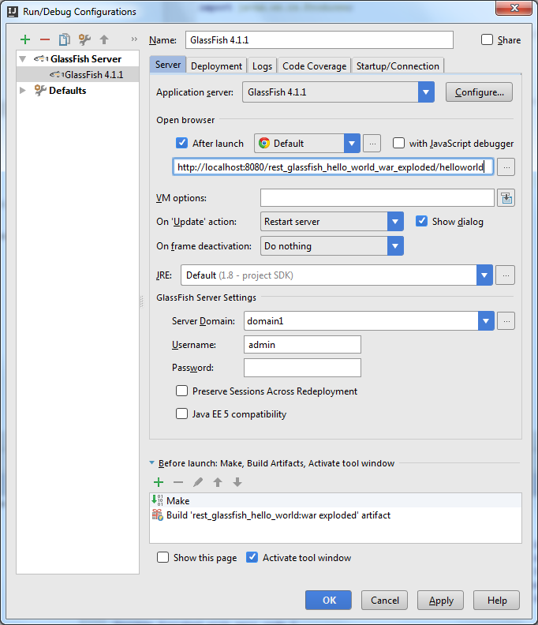

.

**3. Gradle**

Gradle is an open-source build automation system that builds upon the concepts of Apache Maven and introduces a domain – specific language (DSL) instead of the XML form used by Apache Maven for declaring the project configuration. Its supports incremental builds by intelligently determining which parts of the build tree are up-to-date, any task dependent on those parts does not need to be re-executed.

The following is a snippet of the build.gradle file –

group 'GradleThemeDemo'

version '1.0-SNAPSHOT'

apply plugin: 'java'

apply plugin: 'war'

sourceCompatibility = 1.8

repositories {

mavenCentral()

}

dependencies {

// https://mvnrepository.com/artifact/javax.servlet/javax.servlet-api

providedCompile group: 'javax.servlet', name: 'javax.servlet-api', version: '3.1.0'

// https://mvnrepository.com/artifact/org.hibernate/hibernate-core

compile group: 'org.hibernate', name: 'hibernate-core', version: '5.1.12.Final'

// https://mvnrepository.com/artifact/javax.servlet.jsp.jstl/javax.servlet.jsp.jstl-api

compile group: 'javax.servlet.jsp.jstl', name: 'javax.servlet.jsp.jstl-api', version: '1.2.1'

// https://mvnrepository.com/artifact/mysql/mysql-connector-java

compile group: 'mysql', name: 'mysql-connector-java', version: '6.0.6'

testCompile group: 'junit', name: 'junit', version: '4.11'

testCompile group: 'junit', name: 'junit', version: '4.12'

}

**4. Hibernate ORM**

Hibernate is an object-relational mapping tool for Java programming language. It provides a framework for mapping an object-oriented domain model to a relational database. Hibernate handles object-relational impedance mismatch problems by replacing direct, persistent database accesses with high-level object handling functions.

Following is a snippet of the HibernateUtil class –

package com.vaannila.util;

import org.hibernate.SessionFactory;

import org.hibernate.cfg.Configuration;

public class HibernateUtil {

private static final SessionFactory sessionFactory;

static {

try {

sessionFactory = new Configuration().configure()

.buildSessionFactory();

} catch (Throwable ex) {

System.err.println("Initial SessionFactory creation failed." + ex);

throw new ExceptionInInitializerError(ex);

}

}

public static SessionFactory getSessionFactory() {

return sessionFactory;

}

}

**5. MySQL**

It is an open-source relational database management system (RDBMS).

MySQL is fast, reliable, easy-to-use database system used on the web that runs on a server. It is ideal for both small and large applications and uses standard SQL.

MySQL is developed, distributed, and supported by Oracle Corporation.

The data in a MySQL database are stored in tables. A table is a collection of related data, and it consists of columns and rows.

Databases are useful for storing information categorically.

Following is a short summary of the most common MySQL commands used –

**-- Database-Level**

DROP DATABASE databaseName -- Delete the database (irrecoverable!)

DROP DATABASE IF EXISTS databaseName -- Delete if it exists

CREATE DATABASE databaseName -- Create a new database

CREATE DATABASE IF NOT EXISTS databaseName -- Create only if it does not exists

SHOW DATABASES -- Show all the databases in this server

USE databaseName -- Set the default (current) database

SELECT DATABASE() -- Show the default database

SHOW CREATE DATABASE databaseName -- Show the CREATE DATABASE statement

**-- Table-Level**

DROP TABLE [IF EXISTS] tableName, ...

CREATE TABLE [IF NOT EXISTS] tableName (

columnName columnType columnAttribute, ...

PRIMARY KEY(columnName),

FOREIGN KEY (columnNmae) REFERENCES tableName (columnNmae)

)

SHOW TABLES -- Show all the tables in the default database

DESCRIBE|DESC tableName -- Describe the details for a table

ALTER TABLE tableName ... -- Modify a table, e.g., ADD COLUMN and DROP COLUMN

ALTER TABLE tableName ADD columnDefinition

ALTER TABLE tableName DROP columnName

ALTER TABLE tableName ADD FOREIGN KEY (columnNmae) REFERENCES tableName (columnNmae)

ALTER TABLE tableName DROP FOREIGN KEY constraintName

SHOW CREATE TABLE tableName -- Show the CREATE TABLE statement for this tableName

**-- Row-Level**

INSERT INTO tableName

VALUES (column1Value, column2Value,...) -- Insert on all Columns

INSERT INTO tableName

VALUES (column1Value, column2Value,...), ... -- Insert multiple rows

INSERT INTO tableName (column1Name, ..., columnNName)

VALUES (column1Value, ..., columnNValue) -- Insert on selected Columns

DELETE FROM tableName WHERE criteria

UPDATE tableName SET columnName = expr, ... WHERE criteria

SELECT * | column1Name AS alias1, ..., columnNName AS aliasN

FROM tableName

WHERE criteria

GROUP BY columnName

ORDER BY columnName ASC|DESC, ...

HAVING groupConstraints

LIMIT count | offset count

**-- Others**

SHOW WARNINGS; -- Show the warnings of the previous statement

**6. Jasper Reports**

Jasper Reports is an open-source Java reporting tool that can write to a variety of targets, such as a screen, printer into PDF, HTML, Microsoft Excel, RTF, ODT, Comma-Separated Values or XML Files.

It can be used in Java Enabled applications, including Java EE or web applications, to generate dynamic content. It reads its instructions from an XML or .Jasper file.

Following is an example of a code used to call Jasper report from a Java program –

import java.sql.Connection;

import java.sql.DriverManager;

import java.util.HashMap;

import net.sf.jasperreports.engine.JasperCompileManager;

import net.sf.jasperreports.engine.JasperExportManager;

import net.sf.jasperreports.engine.JasperFillManager;

import net.sf.jasperreports.engine.JasperPrint;

// import com.mycompany.helper.* ;

// import com.mycompany.dbi.*;

public class ReportGenerator {

public static void main(String[] args) {

HashMap hm = null;

// System.out.println("Usage: ReportGenerator ....");

try {

System.out.println("Start ....");

// Get jasper report

String jrxmlFileName = "C:/reports/C1_report.jrxml";

String jasperFileName = "C:/reports/C1_report.jasper";

String pdfFileName = "C:/reports/C1_report.pdf";

JasperCompileManager.compileReportToFile(jrxmlFileName, jasperFileName);

// String dbUrl = props.getProperty("jdbc.url");

String dbUrl = "jdbc:oracle:thin:@localhost:1521:mydbname";

// String dbDriver = props.getProperty("jdbc.driver");

String dbDriver = "oracle.jdbc.driver.OracleDriver";

// String dbUname = props.getProperty("db.username");

String dbUname = "mydb";

// String dbPwd = props.getProperty("db.password");

String dbPwd = "mydbpw";

// Load the JDBC driver

Class.forName(dbDriver);

// Get the connection

Connection conn = DriverManager

.getConnection(dbUrl, dbUname, dbPwd);

// Create arguments

// Map params = new HashMap();

hm = new HashMap();

hm.put("ID", "123");

hm.put("DATENAME", "April 2006");

// Generate jasper print

JasperPrint jprint = (JasperPrint) JasperFillManager.fillReport(jasperFileName, hm, conn);

// Export pdf file

JasperExportManager.exportReportToPdfFile(jprint, pdfFileName);

System.out.println("Done exporting reports to pdf");

} catch (Exception e) {

System.out.print("Exceptiion" + e);

}

}

}

**7. JSoup**

Jsoup is a Java HTML parser. It is a Java library that is used to parse HTML document. JSoup provides API to extract and manipulate data from URL or HTML file. It uses DOM, CSS and JQuesy-like methods for extracting and manipulating file.

Following is an example of showing how to extract HTML elements using JSoup –

String html = "<p>An <a href='http://example.com/'><b>example</b></a> link.</p>";

Document doc = Jsoup.parse(html);

Element link = doc.select("a").first();

String text = doc.body().text(); // "An example link"

String linkHref = link.attr("href"); // "http://example.com/"

String linkText = link.text(); // "example""

String linkOuterH = link.outerHtml();

// "<a href="http://example.com"><b>example</b></a>"

String linkInnerH = link.html(); // "<b>example</b>"

**8. HTML**

Hypertext Markup Language is the standard markup language for creating web pages and web applications. With *Cascading Style Sheets (CSS)* and *JavaScript*, it forms a triad of cornerstone technologies for the World Wide Web. Web browsers receive HTML documents from a web server or from a local storage and then render them into multimedia web pages. HTML describes the structure of a web page semantically and originally included cues for the appearance of the document.

Following is an example of a very basic HTML document –

<!DOCTYPE html>

<html>

<body>

<p>This text is normal.</p>

<p><b>This text is bold.</b></p>

</body>

</html>

**9. Bootstrap**

Bootstrap is a free front-end framework for faster and easier web development. Bootstrap includes HTML and CSS based design templates for typography, forms, buttons, tables etc., as well as optional JavaScript plugins. It also gives you the ability to easily create responsive designs.

Following is a very basic example of Bootstrap Code –

<form class="form-inline" action="/action_page.php">

<div class="form-group">

<label for="email">Email address:</label>

<input type="email" class="form-control" id="email">

</div>

<div class="form-group">

<label for="pwd">Password:</label>

<input type="password" class="form-control" id="pwd">

</div>

<div class="checkbox">

<label><input type="checkbox"> Remember me</label>

</div>

<button type="submit" class="btn btn-default">Submit</button>

</form>